6.52: Here, Eq. (6.19) is the most direct. Gravity is doing negative work, so the rope must do positive work to lift the skiers. The force 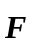 is gravity, and 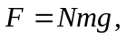 where N is the number of skiers on the rope. The power is then
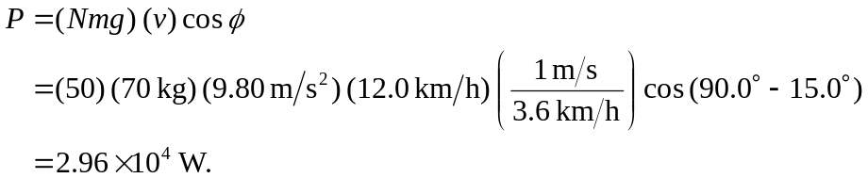
Note that Eq. (1.18) uses as the angle between the force and velocity vectors; in this case, the force is vertical, but the angle 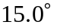 is measured from the horizontal, so 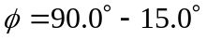 is used.

